Tutorial on a low-power remote Receiver, using eByte's Wake-on-Receive (WOR) implementation with Semtech's sleep-able proprietary radio-based microcontroller).

select the dev board: go to tab Tools/Board/Arduino (my board is a "DOIT ESP32 DEVKIT V1")

don't forget to select in arduino IDE the port: go to tab Tools/Port

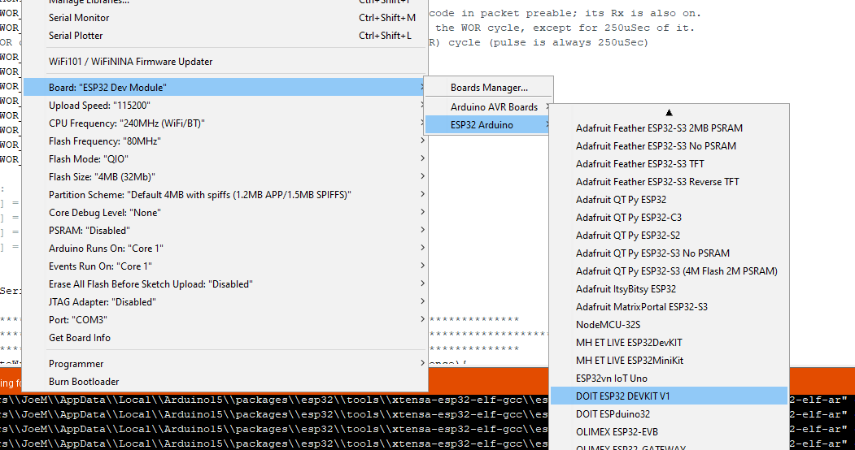

**Parts needed:**

2 ESP32 development boards (e.g. a DOIT ESP32 DEVKIT)

2 eByte Long Range (LoRa) modules: (e.g. the 900 Mhz E220-900T22D, or the 433 Mhz E32-433T30D)

2 antennas (433Mhz or 900Mhz depending on module being used)

2 USB cables to connect ESP boards to the computer

Bread boards (e.g. 4 of the BB400 boards - 2 per each dev board)

#24 wire or jumpers

**Part 1: Wiring up the boards and confirming basic operation**

Wiring Diagram for a 30 pin dev module (36 and 38 pin modules have Gnd and 3.3V on different pins):

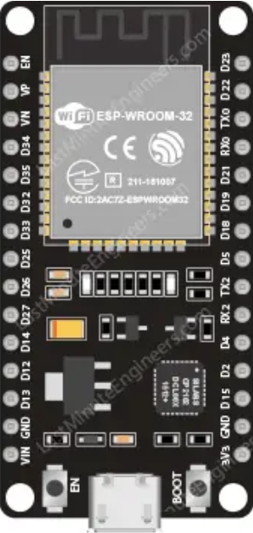

M0 --> GPIO-32

M1 --> GPIO-33

Rx_eByte --> Tx_Esp (GPIO-17)

Tx_eByte --> Rx_Esp (GPIO-16)

Unit Select - +3.3 for Tx unit; Gnd for Rx unit

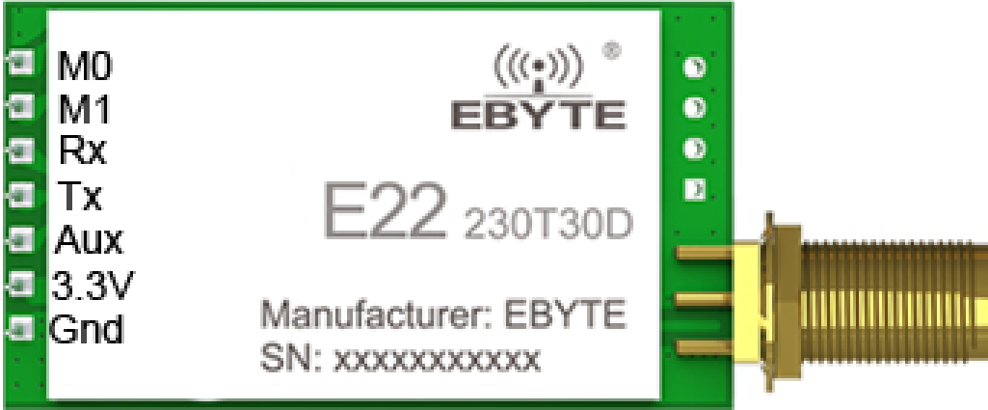

to Gnd for Rx, +3.3V for Tx

The *testWiring* software

- for Arduino IDE:

- for Visual Studio Code IDE: